Video Conversion

In order to load the videos into the video player, they must be converted from .wmv or .avi to .mp4. To do this, we must download the software called “VLC Media Player” to convert one or more videos at a time. To start, click the button “Download Converter” at the top right of the app. Note that this requires an internet connection, if no connection is present please download this software ahead of time (https://www.videolan.org/vlc/index.html).

Once at the download page, you will see the following download button near the center of the screen. Click the down arrow on the right of the button to select your Operating System. Once selected, click the Download VLC button to download the software.

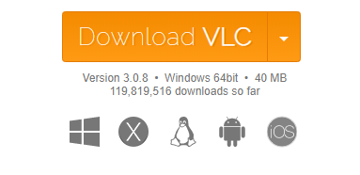

Install the software by following the prompts. You may install it wherever you wish. Once installed, there should be a new icon on your desktop of a traffic cone as shown below.

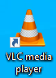

Open the program to find the following screen.

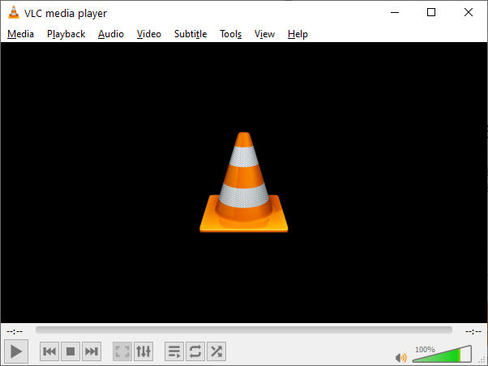

To convert one or more videos, follow this procedure:

1. Click “Media” at the top left of the program. Then click “Convert / Save…”
2. In the new window, click “+ Add…” on the right side to open a file choosing dialog window.
3. Navigate to the location of the videos you wish to convert. Then, select them all by simply highlighting all the videos in the folder. Then click “Open” at the bottom left of the dialog box.
4. The file choosing dialog window should be closed now. You should see the videos you selected in the File Selection box. Now, click “Convert / Save” at the bottom right of this window.
5. A new window should open. In this window, in the center, a dropdown box should be present with three buttons next to it. Click this dropdown box and find the option “Video for MPEG4 720p TV/device” and select it.
6. Finally, click the “Start” button at the bottom right of the window.
7. Now, the videos will be converting. You can see the progress of the conversion from the timer bar at the bottom of the VLC Media Player window. This bar has to fill up once for every video selected. Once all videos are finished converting, the timer will revert to what it looked like in the starting image above with “--:--“ being at the beginning and end of the bar. You may now look in the folder where the videos are stored to find .mp4 versions of each video.
8. Move this .mp4 videos to the Experiment Annotation App’s “Videos” folder.

Note: Conversion time is approximately 5 seconds per 1 minute of video.

Video Player

For the video player, on the video itself, are a set of default controls (similar to YouTube’s functionality). That is, the following default “in video” functionality is available:

* Clicking anywhere in the video to pause and un-pause the video
* Volume controls
* Full screen button
* Picture in Picture ability (the three vertical dots button)
* Using the left and right arrow keys to rewind and fast-forward the video, respectively
* Using the up and down arrow keys to increase and decrease the volume, respectively
* Pressing the space bar to pause and un-pause the video

Furthermore, as stated from the requirements, these functionalities are available from the individual buttons as well. The buttons above the video are the “pre-scoring” video manipulation buttons. From the left to right, the buttons are as follows:

* Play button
* Pause button
* Stop button, which pauses and returns the video to the 0 second mark
* Skip backwards 10 seconds button
* Skip forwards 10 seconds button
* Decelerate time by 2x (minimum video speed is 0.0625x)
* Accelerate time by 2x (maximum video speed is 16x)
* A non-editable text field to show the current video speed
* The load video button. This button opens a file choosing dialog box

Unfortunately, due to security reasons of making a multi-browser application, all videos ***must*** be placed in the corresponding “Videos” folder located in the directory that the primary html file “ExperimentAnnotationTracker.html” is. If you try to load a video from another location, it simply will not load.

However, you can create a shortcut for that folder and place it wherever you wish. On Windows, simply right click on the “Videos” folder in the program directory, hover over “Send to”, then click Desktop (create shortcut). This will create another “Videos” folder on your desktop that mirrors the actual videos folder and can be placed wherever you wish. Just move all of your videos to this shortcut folder and the program will load the videos from either the original “Videos” folder or the “Videos – Shortcut” folder.

Next, the below video buttons are the “scoring” video manipulation buttons. From left to right, the items are as follows:

* The textbox for entering the scoring time in seconds
* The play button. This button starts the video at whatever point it currently is and starts the countdown to 0. Once the countdown hits 0, the video automatically pauses.
* The pause button. This button will pause both the video and the countdown timer.
* The stop button. This button will pause the video, return the video to the 0 second mark, and reset the timer to the previously entered time.